Test Project Module 4
(Advertising and display design)

WSC2013_TP40_M4_actual_EN

Submitted by: Group 4
Susan de Guzman AE
Prenesh Naidoo ZA
Lee Troxell US
Ramón Elías López CO
Teera Piyakunakorn TH
Farid Zaryab IR
Mosaab Al-Awadhi KW

Contents

This Test Project proposal consists of the following documentation/files:
- WSC2013_TP40_M4_Actual_EN.doc (project brief)
- WSC2013_TP40_M4_01_EN.zip (folder of images for the task 1) (refer to Appendix 1.3)
- WSC2013_TP40_M4_02_EN.zip (folder of logos and colour palette for task 1 & 2)
(refer to Appendix 1.4)
- WSC2013_TP40_M4_03_EN.txt (required copy for task 1)
- WSC2013_TP40_M4_04_EN.zip (fonts)

Introduction

We are Sasol
Sasol is an integrated energy and chemical company that leverages the talent and expertise of more than 34,000 people working in 38 countries. We develop and commercialise technologies, and build and operate world-scale facilities to produce a range of product streams, including liquid fuels, chemicals and electricity. Today Sasol has grown to become South Africa’s leading fuel provider and an international player in the energy and chemical sectors.
The South African Sasol Solar Challenge
During September 2014, international and local teams will compete in the Sasol Solar Challenge, an epic two-week country wide endurance challenge involving engineered solar powered vehicles. Teams have designed and built their own innovative vehicles, which will be put to the test as they travel 5400 km across some of the most demanding terrain South Africa has to offer.
Teams from around the globe will descend on South Africa to participate in the Sasol Solar Challenge, the South African leg of the international solar car challenge. Held every two years, this eco-efficiency challenge allows teams from around the world to congregate to demonstrate the sophistication and performance of solar powered vehicles bringing through leading technology.
Ranked as one of the top global events of its kind, the Sasol Solar Challenge is an exciting competition aimed at educating people in the areas of science, innovation, teamwork and business principles. The challenge is a collaborative approach between scholars, students, private individuals and various industry and government partners that will see competitors come together to design and build their own engineering systems, and ultimately drive a solar powered vehicle cross country.
Solar power is flexible and can offer energy solutions across different applications to utilise in a carbon-constrained world. Developing alternative energy technologies, such as solar will contribute to the worlds transition to a low carbon economy.
The 5400km challenge will see the solar cars depart on a two week journey around the country through different terrains in cars that have been conceptualised and designed entirely by the teams participating.
Sasol Solar Challenge key objectives of the competition is to encourage young minds to become involved in innovation, engineering and the sciences.
Project focus: This project is focused on the awareness of sustainable, innovative energy being the driving factor.

Description: There are 2 tasks related to Advertising and Promotional Design.

Target market: Typically directed at public interest for support and awareness of all ages.

Description of project and tasks

TASK 1 – The Sasol Solar Challenge Poster Design

Subject: Every two years a design is conceptualized that encapsulates and visually represents the two-week challenge. The current design demonstrates the message of distance, location, cities and an abundance of energy and vibrancy.

This concept is at the core of all design elements throughout the campaign and should represent the following key words conceptually; dynamic, innovative technology, solar energy, endurance and challenge. As the event is sponsored by a global company, the design should still have a subtle corporate look while being engaging and compelling to the public, creating interest and support.

Description: Let your creative genius side go wild and design a captivating A3 poster with maximum impact. The goal of the poster must be to have a fresh concept that emulates the Sasol Solar Challenge brand.

- Refer to Appendix 1.1 for an example of the 2012 campaign.
- At least two images provided must be merged and placed on the poster.
- Generate an A3 poster using images provided (WSC2013_TP40_MOD4_01_EN.zip)
- Use the two supplied logos on poster (WSC2013_TP40_MOD4_02_EN.zip)
- Apply supplied copy (text) to poster (WSC2013_TP40_MOD4_03_EN.txt)
- Save the final poster-working file in the layout application software format.

Technical specifications for poster

Dimensions: 297 mm X 420 mm (final trimmed size)
Bleed: 3 mm
Colour Mode: CMYK + spot (logo)
Stock: Coated paper
Screen ruling: 150 LPI
Image resolution : 300 PPI
ICC Colour profile : ISO coated v2 (ECI)

You must deliver

• 1 final A3 Poster file saved as a native file.
• 1 final CMYK A3 poster file saved in PDF/x-1a:2001 with 300ppi images using the ICC profile indicated.
• 1 final composite printout, trimmed and mounted on a board for presentation.

TASK 2

Subject: T-shirt & Cap design – promotional material

Description :

You are tasked with marketing material for the Sasol Solar Challenge brand. We want you to design a t-shirt and cap. The design must capture the essence of the event by using your creative artistic flair and adding a touch of brilliance in a clever and appealing design.

The aim of this branding exercise is to create media excitement and create awareness which will position the Sasol Solar Challenge in a positive way.

Refer to Appendix 1.2 for an example of the 2012 campaign.

Target market: General Public of all ages

Instructions

With the description above, design a full colour t-shirt and cap for the Sasol Solar Challenge. Produce an interesting, expressive design. Your design must be witty and intelligent, sending a clear message leveraging media and supporting the solar initiatives.

- Create a t-shirt design (front and back) using the text slogan “commit to the challenge” and “2014”.
- Create a cap design using the text slogan “commit to the challenge” and “2014”.
- Create an accompanying “vector t-shirt and cap” template (back, front and side) that you must use to present the concept design on.
- Save the artwork in A3, landscape, in the native application and pdf formats.
- The Sasol and Sasol Solar Challenge logos must be used in both designs
- The logos must not exceed 90 mm wide on the cap.

Technical specifications
Dimensions: A3 (final trimmed size)
Orientation : Landscape
Image resolution : 250 PPI

You must deliver

• You must illustrate or draw a t-shirt and cap to place your design on, in its native format for the t-shirts.
• Your design is required to have front and back views with at least one spot colour.
• 1 final A3 composite colour printout (fit to page) versions trimmed and mounted on a board.
• 1 final A3 printout with trim marks, registration marks, bleed and colour bar unmounted

Instructions to the competitor

Create a folder on your Desktop called YY_MOD4 (where YY represents the number of your workstation). This folder must include the following subfolders:

- Final_files: it should contain all the files you are supposed to deliver as required in the tasks (PDF, etc.).

- Original_files: it should contain all the files used for the development of your project, properly organized (fonts, links, etc.).

Any file saved out of its respective folder WILL NOT BE EVALUATED.

Note :
- Examples provided are for reference only and should not be used.
- The Sasol colour palette corporate identity guidelines must be followed.
- The colour green must be omitted from all designs

Time limit for this test project:

Equipment, machinery, installations and materials required
• No specific information

Marking scheme

Subjective 10 marks
A.1 Ideas and originality (task 2) 1
A.2 Understanding target market (task 2) 0,5
A.4 Relevance of all aspects in the task (task 2) 0,5
B.1 Effective use of visual composition (including typography) (task 2) 3
B.6 Suitability of the colour choice (task 2) 1
B.7 Quality of the colours used (task 2) 1
B.8 Quality of image manipulation (task 1) 1
B.9 Quality of image colour correction (task 1) 1
B.10 Quality of image blending (task 1) 1

Objective 15 marks
C.1 Resolution of images (task 1) 1
C.2 Colour mode of images (task 1) 1
C.3 Logo dimensions (task 2) 1
C.10 All required elements are present (task 1 and task 2) 1
D.1 Trimmed printouts for presentation (task 1) 1
D.2 Mounted printouts on board for presentation (task 1 & task 2) 1
E.1 Bleed value applied (task 1) 2
E.4 Spot and CMYK colours used as required (task 2) 1
E.6 Printout supplied unmounted (trim marks, registration marks,
bleed and colour bar) (task 1 & task 2) 1
F.1 Source file/native files supplied (linked images, font, ICC profile) (task 1) 2
F.2 ICC profile embedded in the PDF (task 1 ) 1
F.4 All files saved in the right folders (task 1 and task 2) 2

Appendix 1.1
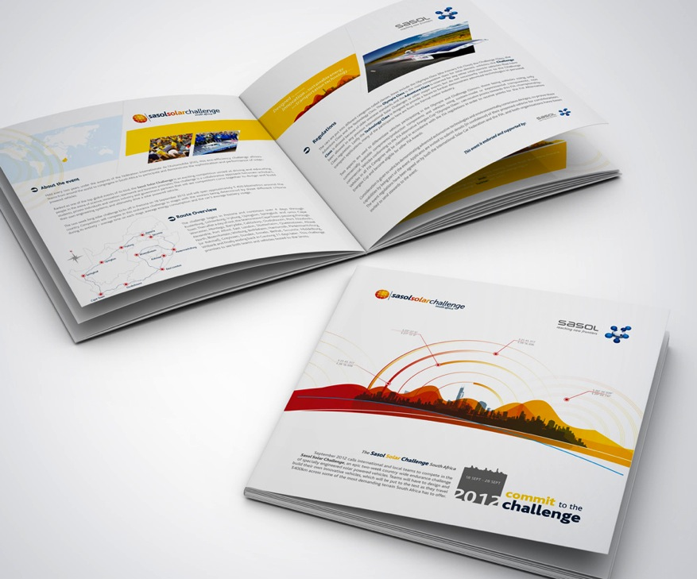

Appendix 1.2

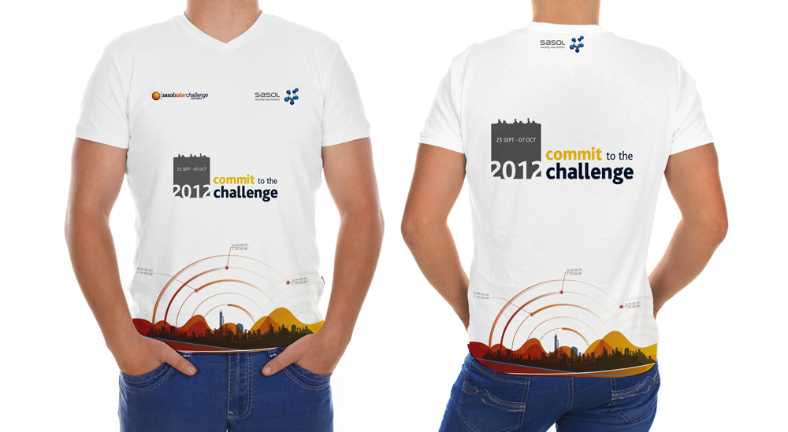
Appendix 1.3
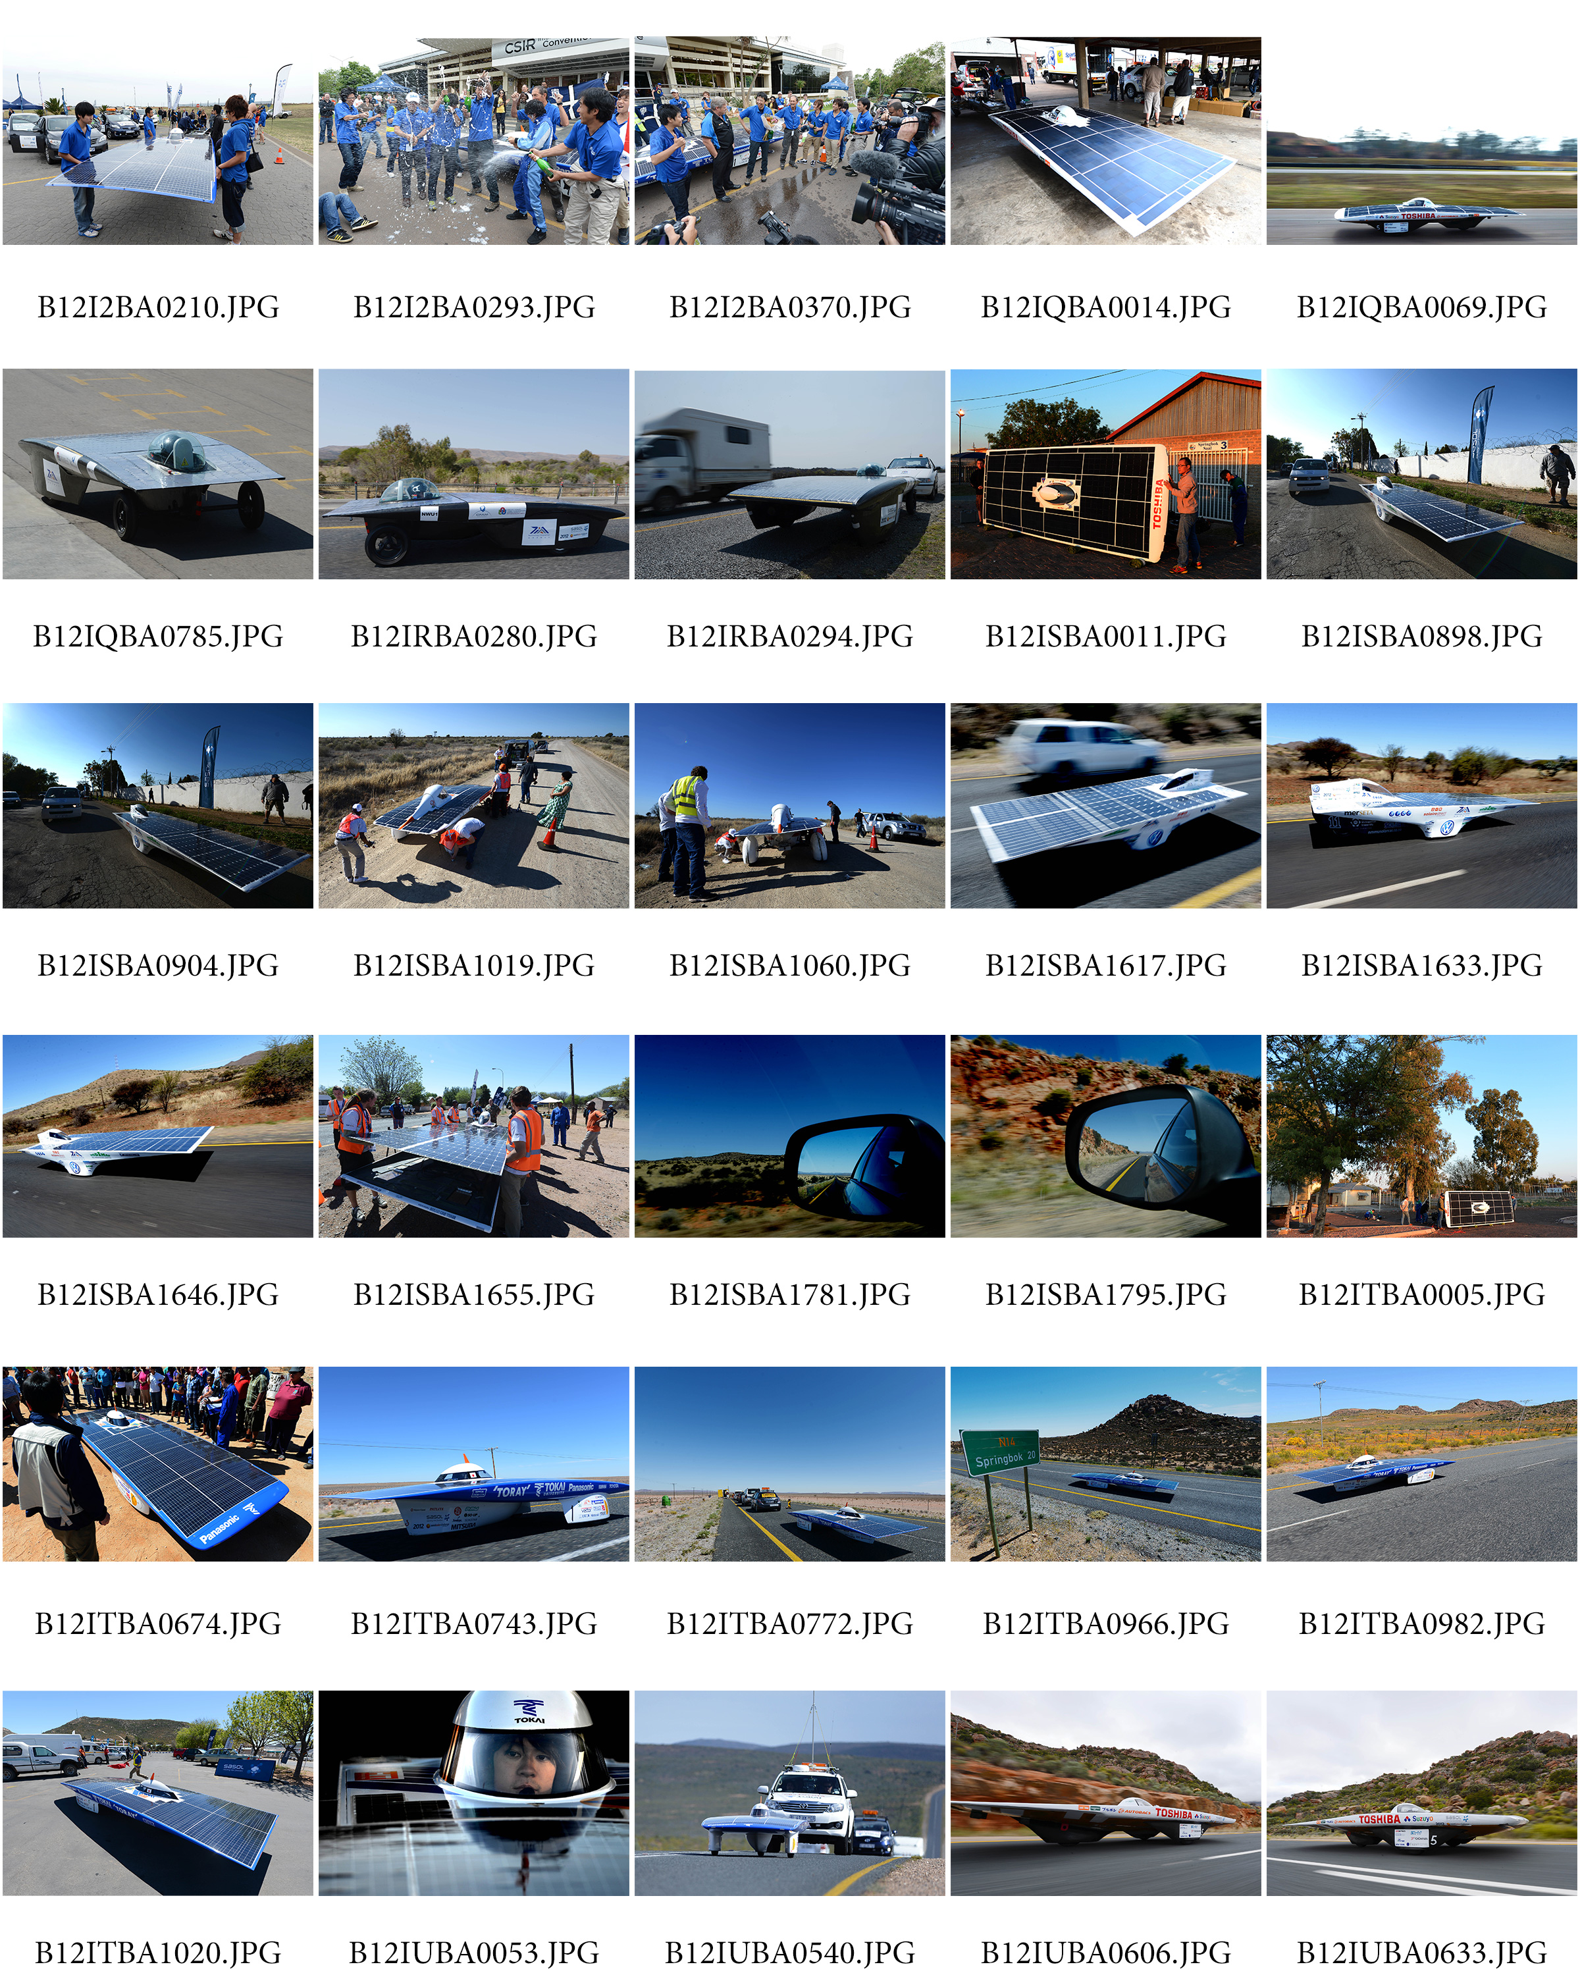


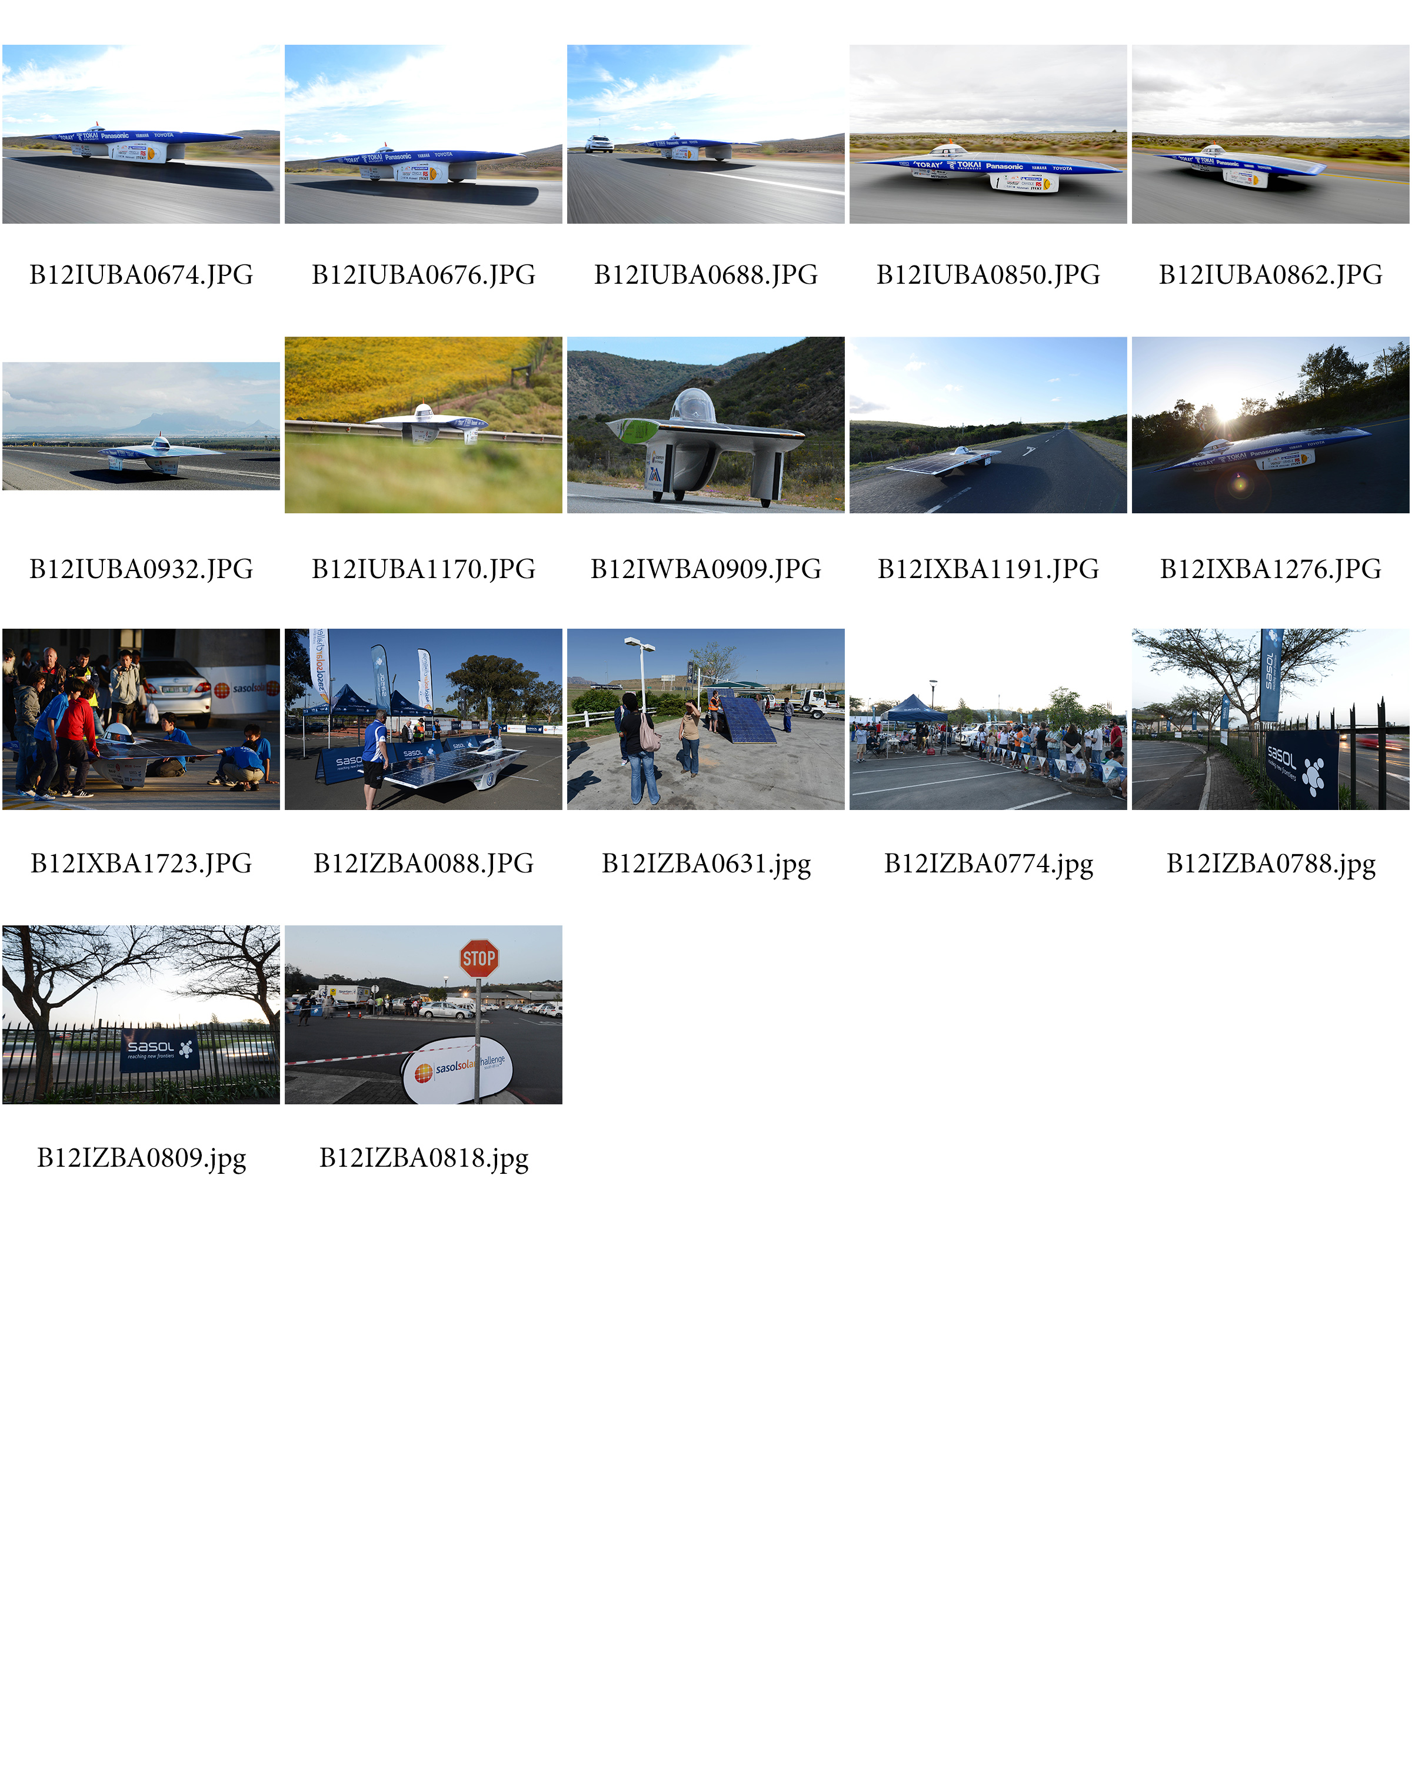

Appendix 1.4
